实验报告
学院（系）名称：计算机科学与工程学院
姓名 |  | 刘志磊 |  | 学号 | 20152174 |  | 专业 | 计算机科学与技术
班级 |  | 一班 |  | 实验  项目 | 实验四：查询优化
课程名称 |  |  |  | 数据库系统 |  |  | 课程  代码 | 0668026
实验时间 |  |  |  |  |  |  | 实验  地点 | 计算机软件实验室
考核标 准 | 实验过程  20分 |  | SQL语句正确性及运行情况 40分 | 实验报告质量(内容与格式) 30分 |  | 实验结果分析与特色创新10分 | 成绩
 |  |  |  |  |  |  | 教师签字：
考核内容 | 评价内容包括考勤与违纪、实验课上表现、编写程序过程、提问等 |  | 评价SQL语句的正确性及运行情况。每个语句4分 | ○完整  ○较完整  ○一般  ○内容极少  ○无报告 |  | ○有分析和创新  ○有分析或创新  ○无
一、实验目的
1. 了解数据库查询优化方法和查询计划的概念
2. 学会分析查询的代价，并通过建立索引或者修改SQL语句来降低查询代价
二、实验内容与要求
基于教材中的student、course、SC表，通过存储过程（要求在报告中写出存储过程），插入多条元组（1万条以上），考虑不同的SQL操作，分析比较执行代价。
存储过程
create procedure insert_stu
@sexflag char(4)='男', @age int=0, @dept char(20)='MA',@i int=5
as
while @i<20000
begin
set @age = 20
if @i%4 = 0
set @age=17

if @i%4 = 1
set @age=18

if @i%4 = 2
set @age = 19

if @i%2 = 0
set @sexflag = '男'
else
set @sexflag = '女'

set @dept = 'MA'

if @i%3 = 0
set @dept = 'CS'
if @i%3 = 1
set @dept = 'IS'

insert into Student values(@i, 'Name'+cast(@i as char), @sexflag, @age, @dept)
set @i=@i+1
end

exec insert_stu

create procedure insert_cou1
@i int = 1000
as
while @i<2000
begin
insert into Course values(@i, 'Course'+ cast(@i as char),1, @i%5)
set @i=@i+1
end
exec insert_cou1

create procedure insert_s_c
@i int =1, @j int =1
as

while @i<6000
begin
set @j=1
while @j<1000
begin
insert into SC values(@i,@j,(@i*@j)%100)
set @j=@j+1
end
set @i=@i+1
end
exec insert_s_c

1． 单表查询
（1）直接查询：查询student表中年龄在20岁以上的学生记录
--1
dbcc dropcleanbuffers
dbcc freeproccache

set statistics io on
set statistics time on
go
select * from Student where Sage > 18;
go
set statistics io off
set statistics time off

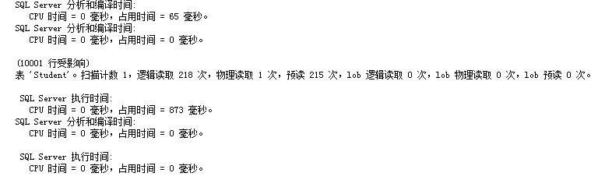
（2）建立索引后，再查询：查询student表中年龄在20岁以上的学生记录
--2
dbcc dropcleanbuffers
dbcc freeproccache

set statistics io on
set statistics time on
go
create index Sage1 on Student(Sage)
select * from Student where Sage > 18;
go
set statistics io off
set statistics time off

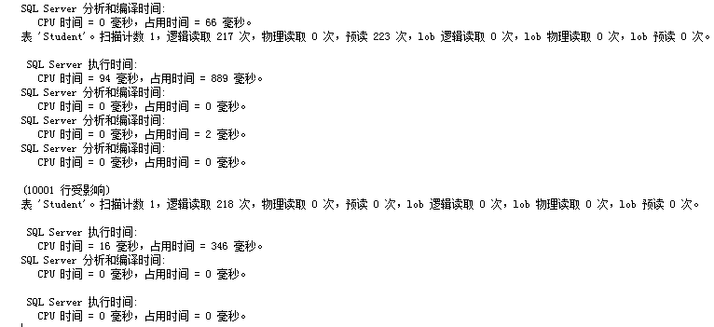
- 表中元组数量少，查询结果所占比例大：查询student表中年龄在20岁以上的学生记录

drop index Sage1 on Student

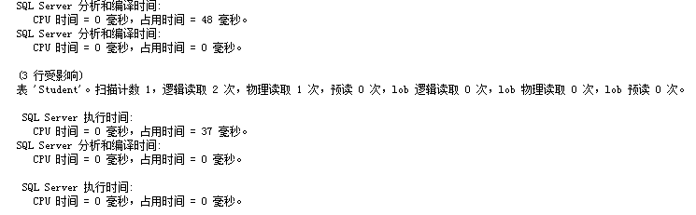

- 表元组数量多，查询结果所占比例小：查询student表中年龄在20岁以上的学生记录
分析以上四种SQL查询的执行效率，并做总结：

数据少时直接查询代价低 ，数据多时如果查询结果占比重少，索引代价低，否则差不多
2.多表查询：基于student、course、SC表，按照以下要求，实现多表查询，并分析比较执行效率。（自行设计查询语句，要求针对同一查询内容，使用以下四种方式）
（1）多表连接查询
dbcc dropcleanbuffers
dbcc freeproccache

set statistics io on
set statistics time on
go
select Student.Sno,Sname
from Student,SC,Course
where Student.Sno = SC.Sno and Course.Cno = SC.Cno and Cname = 'Course10'
go
set statistics io off
set statistics time off
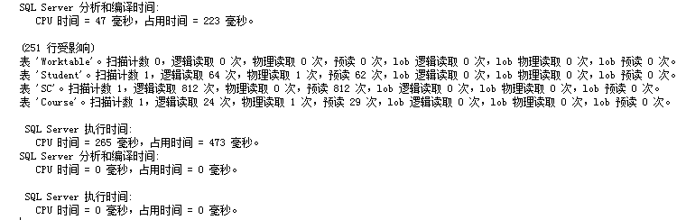

（2）嵌套查询
dbcc dropcleanbuffers
dbcc freeproccache

set statistics io on
set statistics time on
go
select Sno,Sname
from Student
where Sno in(
select Sno from SC where Cno in (
select Cno from Course where Cname = 'Course10'
)
)
go
set statistics io off
set statistics time off
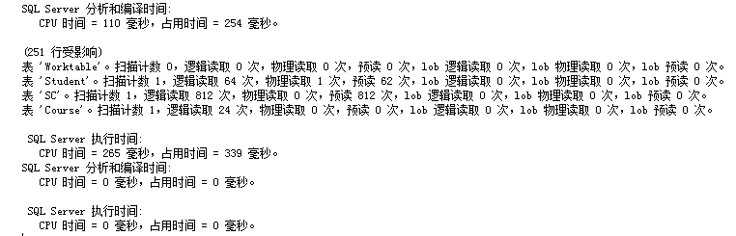

- 建立索引
连接
dbcc dropcleanbuffers
dbcc freeproccache

set statistics io on
set statistics time on
go
create index index1 on Course(Cname)
select Student.Sno,Sname
from Student,SC,Course
where Student.Sno = SC.Sno and Course.Cno = SC.Cno and Cname = 'Course10'
go
set statistics io off
set statistics time off
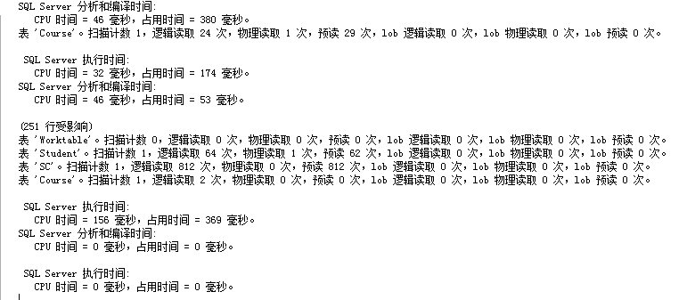
嵌套
dbcc dropcleanbuffers
dbcc freeproccache

set statistics io on
set statistics time on
go
select Sno,Sname
from Student
where Sno in(
select Sno from SC where Cno in (
select Cno from Course where Cname = 'Course10'
)
)
go
set statistics io off
set statistics time off

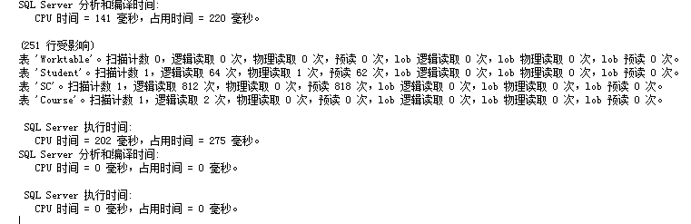

（4）使用游标

分析比较：

3．综合练习
(1) 对于student表，不按照姓名创建索引，查询某个姓名，所需要的时间。
--1
dbcc dropcleanbuffers
dbcc freeproccache

set statistics io on
set statistics time on
go
select * from Student
where Sname = 'Name18478'
go
set statistics io off
set statistics time off

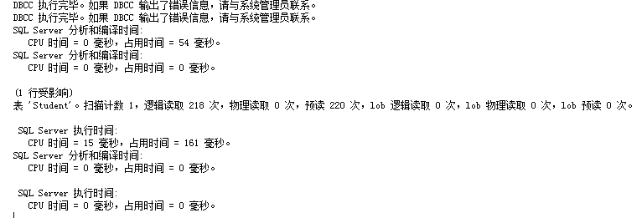
- 对于student表，按照姓名创建索引，查询某个姓名，所需要的时间。
--2
dbcc dropcleanbuffers
dbcc freeproccache

set statistics io on
set statistics time on
go
create index Sname1 on Student(Sname)
select * from Student
where Sname = 'Name18478'
go
set statistics io off
set statistics time off

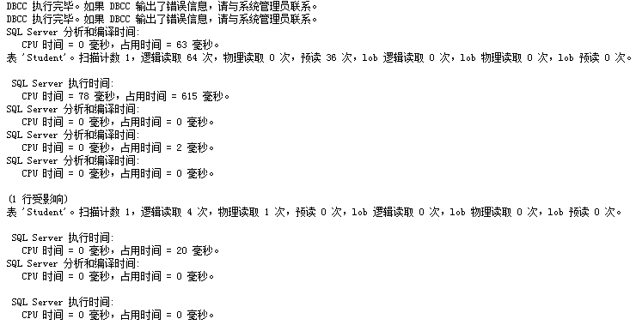
- 对于student表，不按照系别创建索引，查询某个系所有学生，所需要的时间。
--3
dbcc dropcleanbuffers
dbcc freeproccache

set statistics io on
set statistics time on
go
select * from Student where Sdept = 'CS'
go
set statistics io off
set statistics time off

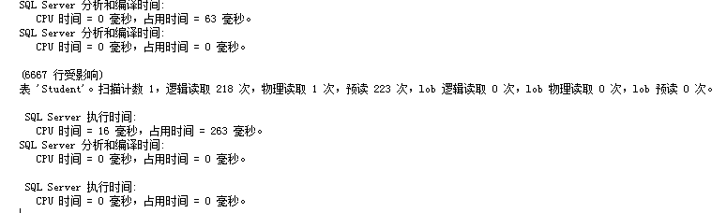

- 对于student表，按照系别创建各种索引，查询某个系所有学生，所需要的时间。
--4
dbcc dropcleanbuffers
dbcc freeproccache

set statistics io on
set statistics time on
go
create index Sdept1 on Student(Sdept)
select * from Student where Sdept = 'CS'
go
set statistics io off
set statistics time off
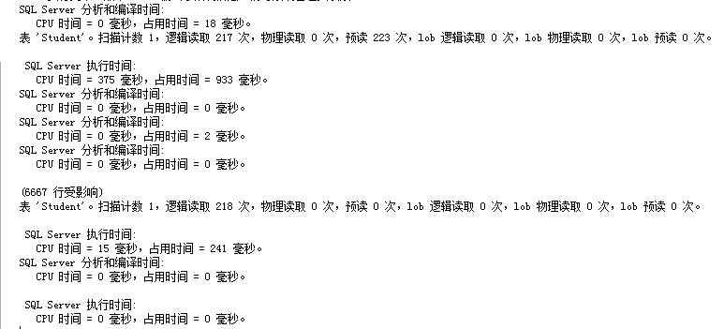
- 查询sc表所需时间。
--5
dbcc dropcleanbuffers
dbcc freeproccache

set statistics io on
set statistics time on
go
select * from SC
go
set statistics io off
set statistics time off
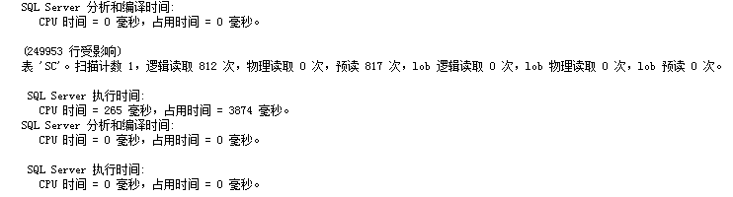
- 将student和sc连接所需时间。
--6
dbcc dropcleanbuffers
dbcc freeproccache

set statistics io on
set statistics time on
go
select * from SC,Student where SC.Sno = Student.Sno
go
set statistics io off
set statistics time off
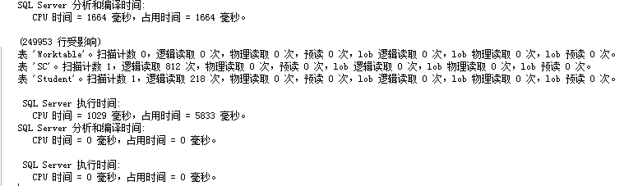
- 将student和sc和course连接所需时间。
--7
dbcc dropcleanbuffers
dbcc freeproccache

set statistics io on
set statistics time on
go
select * from SC,Student,Course where SC.Sno = Student.Sno and SC.Cno = Course.Cno
go
set statistics io off
set statistics time off
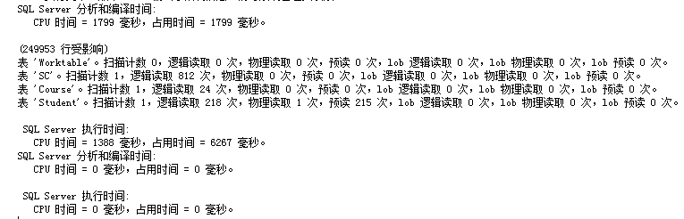
(8)查询选修了“数据库”学生的学号姓名，分别用嵌套和连接的方法，观察两种方法所用的时间。
--嵌套
dbcc dropcleanbuffers
dbcc freeproccache

set statistics io on
set statistics time on
go
select Sno,Sname
from Student
where Sno in(
select Sno from SC where Cno in (
select Cno from Course where Cname = 'Course10'
)
)
go
set statistics io off
set statistics time off

--连接
dbcc dropcleanbuffers
dbcc freeproccache

set statistics io on
set statistics time on
go
select Student.Sno,Sname
from Student,SC,Course
where Student.Sno = SC.Sno and Course.Cno = SC.Cno and Cname = 'Course10'
go
set statistics io off
set statistics time off
4.实验要求：
1）在表中插入相应记录；
2）执行SQL语句；
3）认真完成并按时提交实验报告，在实验报告中附执行SQL语句、优化等分析比较截图；
4）整理上机步骤，总结经验和体会。

【实验过程记录（源程序、测试用例、测试结果及心得体会等）】

